SG3 User Manual

Denny Dyer, Chris Imgarten, Kevin Linden, Aaron Little, Matt Willerding

CMP_SCI-4500-001-11806-2025SP-Intro to Software Profession

Submitted:

05/06/2025

SG3 User Manual

1. Introduction
Welcome to SG3.
This program is a tool designed to help you analyze species abundance data. You provide a data file listing how many individuals of different species were counted on various dates, and SG3 reads this file and then creates several summary reports. It also saves four new text files containing different summaries of your data to help you spot patterns and trends.

What You Need
- The SG3 Program: This manual assumes SG3 has been installed or placed in a folder on your computer.
- Your Data File: You need your species abundance data saved in a specific CSV format.
- File Location: Your .csv data file must be located in the same folder as the SG3 program itself.

What Files SG3 Creates
When SG3 runs successfully, it will:
- Show several summary reports directly on your screen.
- Create four new text files in the same folder where you ran SG3:
Species.txt: A list of the species found in your data file.
DatedData.txt: A list of the dates found in your data file.
PresentAbsent.txt: A table showing whether each species was present (1) or absent (0) on each date.
HeatMap.txt: A table showing whether the abundance count for each species on each date was relatively Low (L), Medium (M), or High (H) compared to its own range over all dates.

Before You Start
- Make sure you have opened your computer's command line interface (like Terminal or Command Prompt.
- Make sure you are in the folder containing both installed program and your .csv data file that you intend to use
- Double check that your data file is saved with a .csv extension (data.csv).

2. Running the Program

How to Begin
Once you are in the correct folder in your command line interface, you can run the program by typing its name and pressing ‘Enter’. For instance, if your program files are located in the directory:
‘C:\SG3’
simply type (without quotes):
‘sg3’
as shown in the screenshot below:
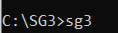

First Screen
After you press Enter, the first thing SG3 does is display a brief message explaining what it will do.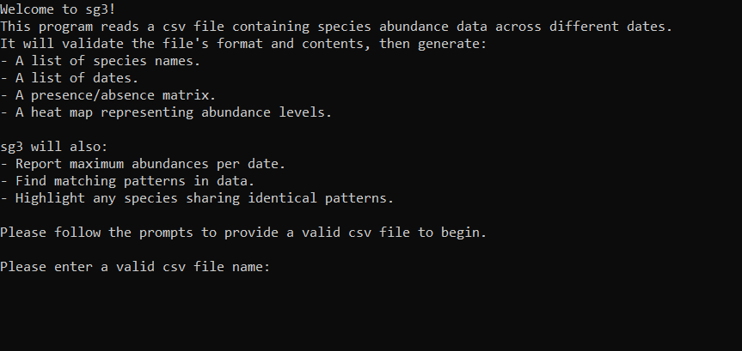

3. Inputting Your Data File

The Prompt
After the introductory message, SG3 will ask you to enter the name of your data file:
Please enter the name of your input CSV file:
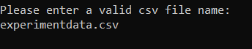

Inputting the File Name
Once the program prompts you, type the full, exact name of your data file, making sure to include the .csv extension at the end. For example, if your file is named ‘experimentdata.csv’, you would simply type (without quotes):
- ‘experimentdata.csv’
Press Enter after typing the filename.
Case Sensitivity: The .csv extension is not case sensitive (.CSV, .cSv are all okay).

File Location Reminder
The .csv file you name must be in the same folder you are currently that you are executing SG3 from.

Common Issues
- Wrong Extension: If you type a filename that doesn't end in .csv, SG3 will show an error message indicating you typed in the wrong extension. Just verify your file is a proper .csv format file retype it correctly.
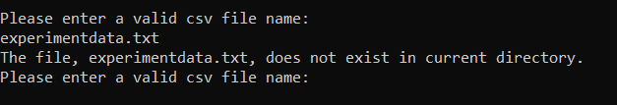

- File Not Found: If you type a filename that ends in .csv but the file doesn't exist in the current folder (or you misspelled the name), SG3 will show an error message indicating the file doesn’t exist and ask for the filename again. Double check the spelling and make sure the file is in the correct folder.
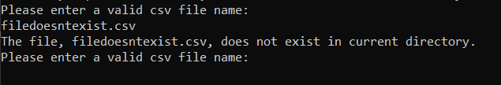
SG3 will keep asking until you provide a valid filename (.csv extension) that matches a file it can actually find and open in the current folder.

4. Required Format for Input File
For the program to function properly, it’s important that your data is formatted correctly. If SG3 stops with an error after you've entered a valid filename, it will almost always be because the data inside your .csv file isn't formatted exactly as the program expects.
Your .csv file needs to look like this simple table structure in the .csv format below:
Correct .csv Format Example
,Organism A1,Organism B12,Organism_D4
01/05/1999,56,0,3
02/17/1999,12,4,0
03/05/1999,11,1,3

The first row is a blank cell followed by the species names. Each subsequent row will have the following data: Date, Count for A1, Count for B12, Count for D4, where date is the date of the count and the following numbers are the counts on that date(which we refer to as ‘abundance counts’) for the individual species given in the header row above.

Formatting Requirments:
Row 1 (Header Row):
- The header row must start with a comma (representing an empty cell in a spreadsheet). This is followed by your species names, separated by commas.
- Species names can contain letters, numbers, periods (.), underscores (_), and spaces.
- Important: Species names cannot contain commas.
Data Rows (All subsequent rows):
- Each data row must start with a date in MM/DD/YYYY format. Leading zeros are optional 1/5/2023 is okay, as is 01/05/2023). The year must have four digits (1/5/23 is not allowed).
- After the date, there must be a comma.
- Then, provide the abundance count (the number of individuals observed) for each species listed in the header row, in the same order, separated by commas.
- Abundance counts must be zero or positive numbers. They can be whole numbers (56) or have decimals ( 4.2). Negative numbers are not allowed.

Consistency between the header and entry rows:
- Every single data row must have the exact same number of abundance counts after the date.
- This number must match the number of species names listed in the header row.

You can create or edit these files using simple text editors or spreadsheet programs, but make sure to save or export as a .csv file.

5. What Happens Next (Program Workflow)
Once SG3 successfully opens and starts reading your correctly named .csv file:
Checking Your File: SG3 reads the file line by line. It carefully checks:
- The header row structure.
- That there's at least one data row, but not more than 999.
- That each data row starts with a valid MM/DD/YYYY date.
- That each data row has the correct number of abundance counts (matching the number of species).
- That all abundance counts are valid numbers (zero or positive, integer or decimal).
- If it finds any error during this check, it will stop, print an error message explaining the problem and the line number, and wait for you to press Enter before closing. See Troubleshooting section below.
Summary Info: If the file passes all checks, SG3 will report how many different species (columns) and how many different dates (data rows) it found. It will then pause and ask you to press Enter to continue.
Generating Outputs: After you press Enter, SG3 performs its analyses and generates the various reports displayed on screen and output files as described below.

6. Understanding the Results
SG3 provides results both directly on the screen and by creating new files in your working folder.

On Screen Reports
SG3 will begin by listing the number of species being tracked along with the number of dates recorded.
It will prompt you to press enter and then display the following reports:
- Maximum Abundance Report:
  - For each date in your file, this report lists the highest abundance count recorded on that day and identifies which species had that count. (There might be ties if multiple species had the same max count).
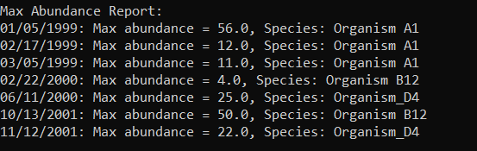

- Presence/Absence Grouping Report:

  - This report looks for dates that have the exact same pattern of species being present (count greater than 0) or absent (count equals 0). It groups these dates together. For example, it might report that on 03/05/1999, 06/11/2000, and 10/13/2001, all species were present (represented as a 1,1,1 pattern if you have 3 species).
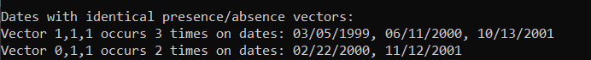

- Heat Map Display:

  - This report gives you a quick visual overview of abundance levels relative to each species' own range. For every species, SG3 finds its minimum and maximum count across all dates. It then divides this range into three roughly equal parts: Low, Medium, and High. The display shows a grid with dates as rows and species as columns, filled with ‘-’ for low, ‘o’ for medium, or ‘X’ for high. This helps you see if a species’ count on a particular date was low, medium, or high for that specific species.
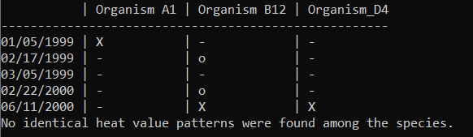

- Species Similarity (HML) Report:

  - This report looks for different species that show the exact same pattern of Low, Medium, and High values across all the dates. If it finds any groups of species with identical L/M/H patterns, it lists the pattern and the names of the species that share it. For instance, given the data:
,Organism A1,Organism B12,Organism_D4
01/05/1999,56,0,3
02/17/1999,12,0,3
Where Organism B12 and Organism_D4 both have identical abundance counts, the output will show the following:
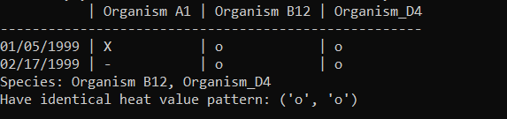
  - If no species share patterns, for instance:
,Organism A1,Organism B12,Organism_D4
01/05/1999,56,77,14
02/17/1999,12,0,99
02/17/1999,22,52,33
it will state that:
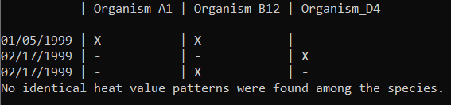

- Completion Prompt: After displaying all reports, SG3 will show a final message asking you to press Enter to finish the program.

Output Files
While running, SG3 creates the following four files in the same folder where you ran the program. From this folder, you can open and view these reports with a text editor or import them into spreadsheet software.
- Species.txt
  - This report contains a list of all the species names found in the header row of your input file, one name per line, in the original order. For example, for three species:

Organism A1
Organism B12
Organism_D4

- DatedData.txt
  - A simple list of all the dates found in your input file, one date per line, in the original order. If you had three dates in your input file, you would have the following output in the file:

01/05/1999
02/17/1999
02/17/1999

- PresentAbsent.txt
  - This file indicates whether a species was detected or not. It looks very similar to your input .csv file, but the abundance counts are replaced by 1s and 0s. A 1 means the species was present (original count > 0) on that date, and a 0 means the species was absent (original count = 0). It includes the header row with species names.

  - Example: PresentAbsent.txt Contents
,Organism A1,Organism B12,Organism_D4
01/05/1999,1,0,1
02/17/1999,1,1,0
03/05/1999,1,1,1

- HeatMap.txt
  - This file contains the data used for the on screen heat map. Each line starts with a date, followed by L, M, or H codes for each species (in the same order as the header row). Remember, L/M/H represents whether the original abundance count was in the low, medium, or high part of that specific species' range across all dates.

- Example: HeatMap.txt Contents
01/05/1999 H M M
02/17/1999 L M M

7. Troubleshooting Common Errors
If SG3 stops early and shows an error message, the most likely issue is that there's a formatting issue in your input .csv file that needs to be fixed. SG3 will tell you the line number where it found the problem.
General Troubleshooting:
- Read the error message carefully. It will often point directly to what the problem is and where it exists on your data file.
- Open your .csv file in a text editor or a spreadsheet program and go to the line number mentioned in the error message.
- Compare the format on that line to the format specified in the Required Format for Input File section above.
- Correct the error, save your .csv file, and try running SG3 again.

Specific Error Message Examples:
  - Error Message:
Error on line [N]: Invalid date format ‘[INCORRECT DATE]’
  - Problem: On line number N, the date is not in the required MM/DD/YYYY format.
  - Fix: Correct the date format on line N in your CSV file. In the example above change ‘200’ in the year field to the correct 4 digit year.

- Error Message:
Error on line [N]: Incorrect number of entries

  - Problem: On line number N, SG3 expected to find X abundance counts (based on the number of species in your header row), but some number more or less than X. This probably means you have too many or too few commas separating the numbers on that line.

  - Fix: Check line N in your CSV file. Make sure there is exactly one number for each species, separated by commas, after the date.
  - Example:
Supposing you have the following input on line 4 :
‘03/05/1999,11,1,3,’
There is an extra comma at the end of the entry that needs to be removed as show below:
‘03/05/1999,11,1,3’

- Error Message:
Error on line [N]: Illegal number ‘[X]’
  - Problem: On line number N, the value value X is not a valid abundance count. This could be because it's negative, or it contains letters or symbols other than a decimal point.
  - Fix: Check the number value X on line N in your CSV file. Ensure it's zero or a positive number (whole or decimal).
  - Example: In the screenshot below, the error message shows there is a letter ‘A’ on line 3. To fix this error, this value needs to be changed to a valid numeric entry.
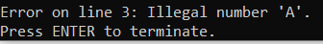

- Error Message:
File must contain between 1 and 999 data lines (found value [X]).

  - Problem: Your file has too few (0) or too many (over 1000) lines of data after the header row.
  - Fix: Check your file structure. Ensure you have at least one valid data row and fewer than 1000 data rows.

Correcting any of these errors and saving the file should allow SG3 to proceed past that point when you run it again.

This concludes the User Manual. Thank you for using SG3.

